MISSION
Empower individuals to live healthy purpose-filled lives on their terms.

VISION
To engage individuals, families, and communities in personalized whole-self-care based on a boundless belief in personal potential.

VALUES
Unyielding Empowerment
Relentless Resiliency
Inspirational Integrity
Active Accountability
Radical Respect

Iowa Code Chapter 32IJ.22 (Operating While Intoxicated) requires the completion of the following for reinstatement of a driver's license:
- Complete the 12-hour Iowa Course for Drinking and Driving (DUI).
- Complete a substance abuse evaluation at a substance abuse program licensed under Chapter 125 and follow any treatment recommendations of the evaluation.
- Pay a civil penalty, reinstatement fee, pass required examinations, and any additional requirements.
Some students may be assigned to take a residential weekend program in lieu of jail requirements [Section 321J.2, subsection 2, paragraph a, subparagraph (1), 2003 Code Supplement].
To learn more about our services please contact us at:
320 North Eisenhower Avenue
Mason City, IA 50401
Phone: (641) 424-2391
Toll Free: 1-866-429-2391
www.prairieridge.net

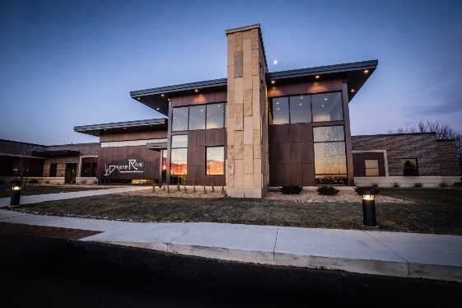

Prairie Ridge Intoxicated Driver Education Jail Diversion Program (PRIDE)
______________________

Providing comprehensive prevention, intervention, and treatment services to the communities of North Iowa and beyond

Weekend/OWI Jail Program:
The Prairie Ridge Weekend Jail/OWI Program is a program designed to fulfill both the Iowa Department of Transportation (DOT) education requirements and the court-mandated jail time for Operating While Intoxicated (OWI) offenses.

In order to attend this program, participants must have been court ordered by a judge.

As a participant, you will receive the PRIME For Life education required by the State of Iowa in order to be eligible to reapply for your driver’s license.

This program begins on Friday with registration at 5:00 p.m. Participants will receive four hours of PRIME for Life education on Friday, eight hours on Saturday and eight hours on Sunday. The program will end promptly at 5:00 p.m. on Sunday.

Location:
This program is held at the Mason City Holiday Inn Express:
3041 4th Street SW, Mason City, IA
Phone: (641) 424-1200

Programming:
During the program, participants will receive 20 hours of PRIME for Life education. PRIME for Life is the only education curriculum approved by the State of Iowa. It is an evidence-based program recognized by the National Registry of Evidence-Based Programs and Practices (NREPP).

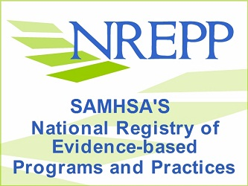

For more information on the program, please visit www.askpri.org.

Cost:
This program costs $500. Included in the cost of this program is the $180 DOT-mandated education fee, two nights of hotel rooms, and meals for the weekend. *Fees subject to change

Frequently Asked Questions:
How will the court and DOT be notified of my completion?
Your instructor will notify the courts and DOT of your successful completion of the program within three business days after your program.
Will I be given breaks?
Breaks are given every 1 -1 ½ hours during the education portion of the program.
Will I be allowed to leave the hotel or my hotel room?
Since this program also serves as jail time, as ordered by a judge, all participants are required to remain on site the entire weekend and remain in their hotel rooms unless instructed otherwise by Prairie Ridge staff members.
How can I pay?
Prairie Ridge accepts MasterCard, Visa and Discover as well as money orders and cash. Payment is due at the time of registration. Notice will not be sent to the court or DOT until payment is validated.
Are there staff members available when I am not in class?
Prairie Ridge staff members will be on-site from 5 p.m. Friday to 5 p.m. Sunday.

